sBefore going further, please check these two important parts:

First, What to do in each of the steps!

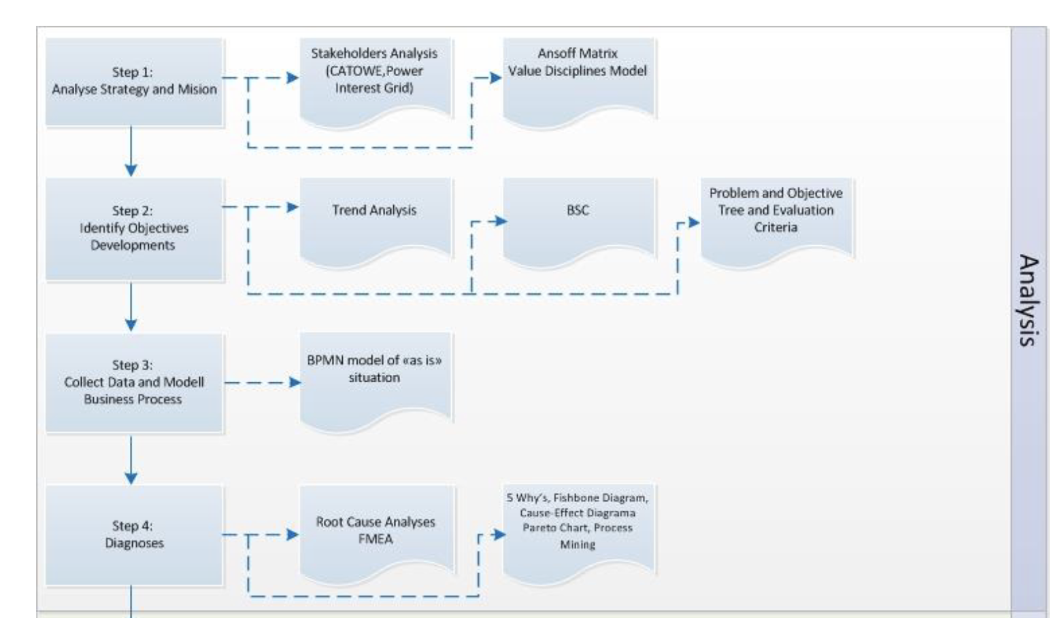

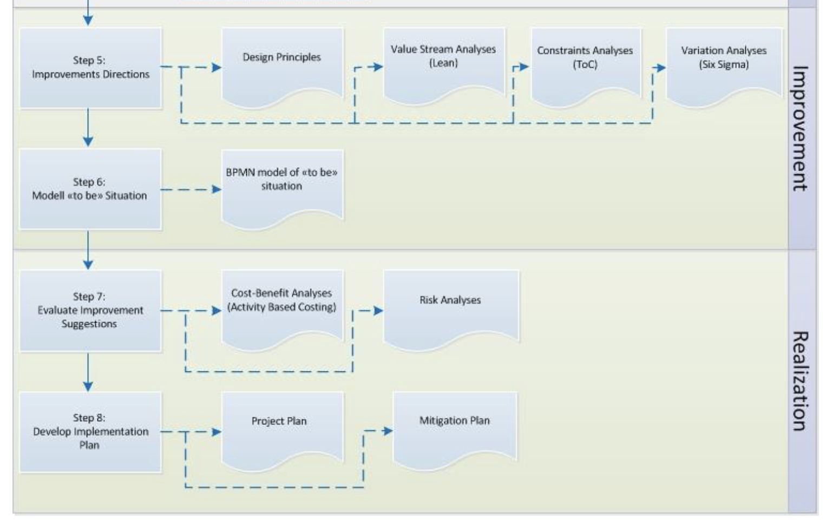

Second, Here is the checklist for the Report, from Reader Book

**We should make based on this! Please read first before putting you data into here**

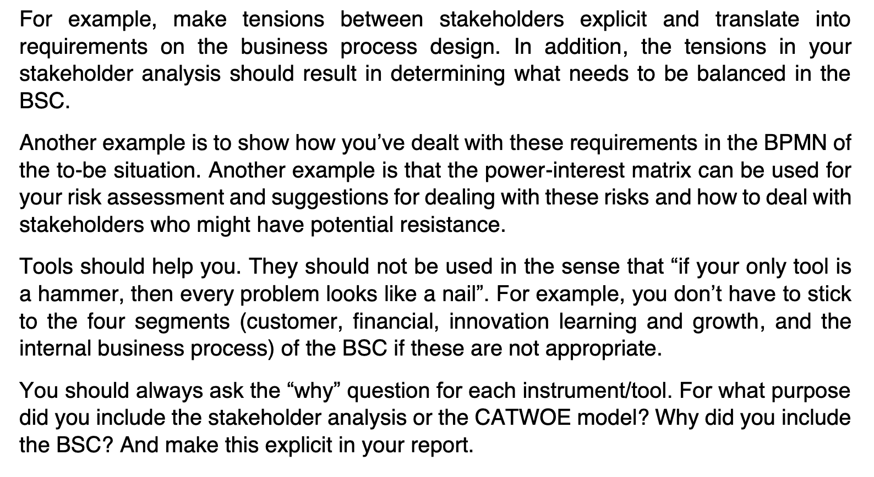

Table of Contents

Abstract

Introduction

Overview of DHL

* Background
* Vision, Mission, and Strategy
* Market Trend Analysis
* Stakeholder Analysis
* Balanced Score Card
* Strategy Map
* Selected Critical Business Process

The Current Process

* Involved Stakeholders
* Model and Description
* Assumptions

Diagnosis of the Issues

* Customer Requirements
* SWOT Analysis
* The Issues (Problem Definition)
* Root Cause Analysis

The Improved Process

* Model and Description
* Assumptions

Implementation of the New Process

* Cost-Benefit Analysis
* Project Plan
* Mitigation Plan and Risk Analysis

Conclusions

Table of Contents

Introduction 7

Overview of DHL 9

The Current Process 10

Diagnosis of the Issues 11

The Improved Process 12

Implementation of the New Process 13

# 

# Introduction

Here, give overview about the importance of DHL and why it is one of critical super important company. Give overview of the world condition, etc etc

Example:

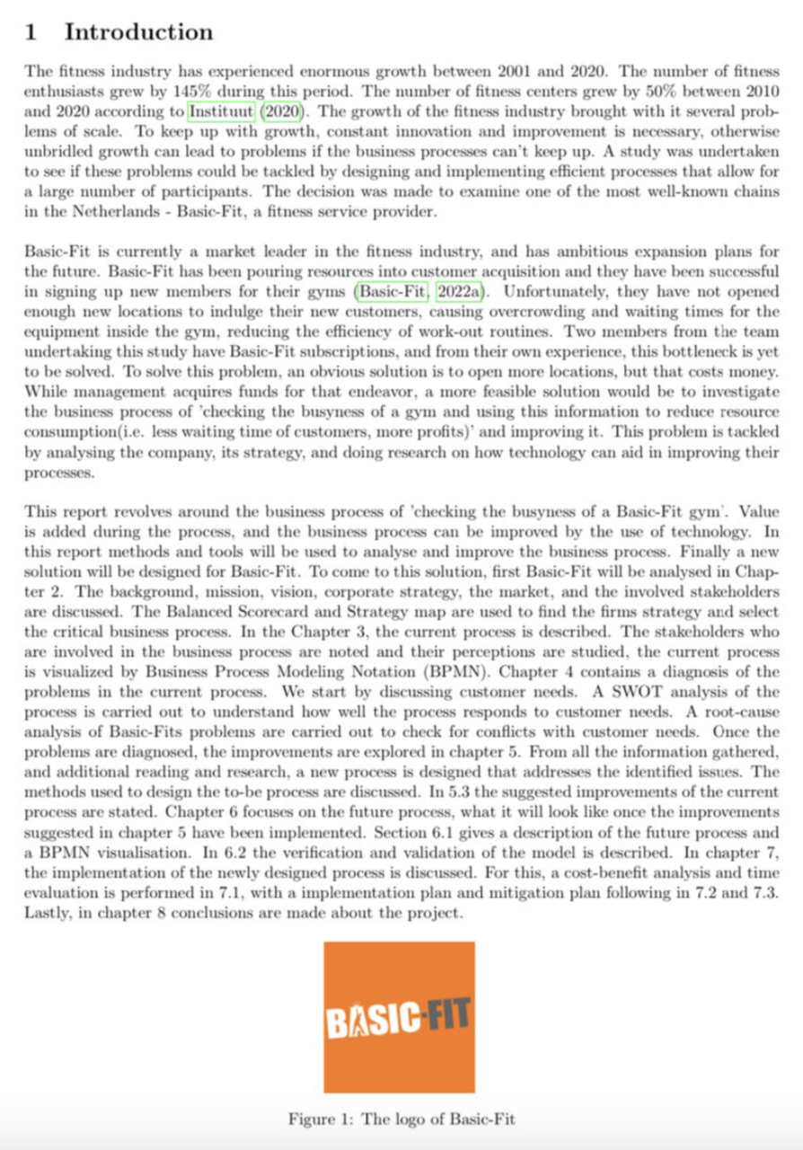

# Overview of DHL

# 2.1 – Background

The genesis of DHL dates back to 1969, marking the inception of a global powerhouse in logistics and express delivery. What began as a disruptive idea to expedite cargo documentation delivery has transformed into a global network spanning over 220 countries and territories. DHL's journey from its humble beginnings to becoming a subsidiary of the world's leading postal and logistics company, Deutsche Post DHL Group, is a testament to its pioneering spirit and commitment to excellence.

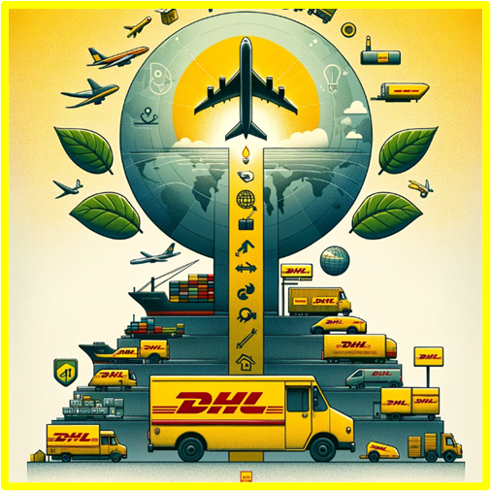

Over the decades, DHL has not only expanded its service portfolio but also embraced technological advancements and sustainability initiatives. In response to the escalating demands of e-commerce and the imperative for green logistics, DHL has set ambitious goals. These include achieving zero emissions by 2050, a commitment that reflects the company's dedication to environmental stewardship and its proactive approach to addressing the challenges of modern logistics.

DHL's operational model, characterized by its extensive network of sorting centers, delivery vans, service points, and innovative solutions like locker walls, is designed to cater to the dynamic needs of global commerce. Through strategic investments in digitalization and sustainable practices, DHL aspires to redefine the standards of delivery services, ensuring reliability, efficiency, and minimal environmental impact.

**2.2 – Strategy, values and mission of DHL**

*“Strategy 2025 – Delivering excellence in a digital world”* – This is the slogan DHL has created to define their **strategy**. As a globalist logistics leader, DHL is an enabler of global trade. It is therefore important for them to be able to connect people and markets (DHL Group, 2023). According to DHL, the four most important trends that have impacted the logistics industry in recent years are **globalisation**, **digitalisation**, **sustainability** and **ecommerce.** As such, it is important to lay the foundation for the future to secure their position and successes in the industry. This includes *improving and increasing the rate of digital transformation in all business divisions* and focusing more consistently on harnessing ways to *successful long-term growth of core logistics businesses* (DHL Group, 2023).

DHL are committed to their **purpose**, **vision** and **values** in order to maintain a consistent strategy. The three components are mentioned in Figure 2.1(DHL Group, 2023). These three components are complemented by the mission of the DHL Group to commit themselves to excellence – *Excellence. Simply Delivered (*DHL Group, 2023)*.* According to DHL, their mission is accomplished as long as they are committed to sustainably implementing three core principles to achieve their purpose:

* *Employer of Choice – Motivated and skilled employees deliver exceptional quality*
* *Provider of Choice – Exceptional quality delights our customers and leads to loyalty*
* *Investment of Choice* *– Customer loyalty leads to profitable growth*

(DHL Group, 2023)

The common DNA among employees, which provides the necessary behaviours, tools and programs to support their mission, allow employees to succeed in each core principle (DHL Group, 2023). Below is a schematic representation of the strategy of the DHL Group, which includes their purpose, vision, values and mission.

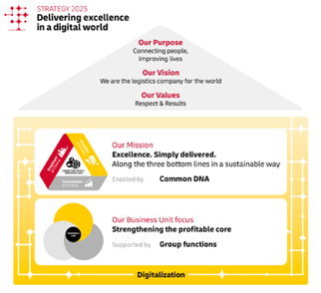

**Figure 2.1 – Schematic Representation of the Strategy of DHL**

**2.3 – Analysing the strategy, values and mission of DHL**

In order to understand the strategy of DHL, it is important to analyse the information DHL has provided us on how and what they want to achieve through their strategy. In order to perform an analysis of the information about DHL, two tools are used – *The Ansoff Matrix* and *The Value Discipline Model.*

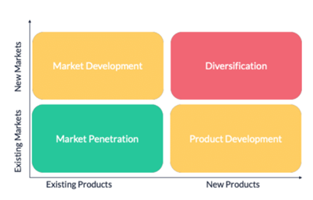 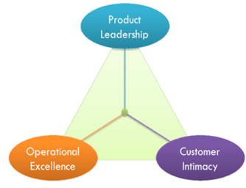

**Figure 2.2 – The Ansoff Matrix (Stanke, 2024) (Left) and The Value Discipline Model (Eelants, 2023) (Right)**

**The Ansoff Matrix** is used to understand the strategy of the company in terms of their interests and power. It helps to understand the business processes that are crucial to support the strategy of DHL (Janssen, 2024). Considering the Ansoff Matrix, the main focuses of DHL are market penetration and product development.

**Market penetration** involves increasing market shares within existing markets with existing products and services. As such, DHL focuses on improving digital transformation in all business divisions and focuses on securing advantages from harnessing long-term growth of core logistics businesses as discussed in Section 2.1.

**Product development** involves the entering of existing markets with new products or services. These include new features or ways of delivery that could appeal to customers such as a decrease in average delivery time or make delivery services more efficient and environmental-friendly. Therefore, DHL tries to implement their strategy through the combination of market penetration and product development, in which they try to improve their current business processes and implement new products and services to secure their strategy, values and mission.

**The Value Discipline Model** is used to understand which strategy the company has chosen to deliver their values. The value disciplines are – *Operational Excellence, Customer Intimacy* and *Product Leadership* (Treacy & Wiersema, 1993). As the DHL Group aspires to be the first choice of people worldwide (DHL Group, 2024), it is important for DHL to maintain their leading position in the industry. Therefore, Operational Excellence is a vital strategy for DHL as it will be important to deliver packages globally in an efficient and reliable way.

**Operational Excellence** focuses on delivering quality products or services at competitive prices, ensuring convenience in requiring them (Janssen, 2024). As DHL seeks to optimise each business unit through increased digital transformation, one could argue in favour of operational excellence. In addition, DHL attempts to connect people and improve their lives by providing them with the best results possible, whilst respecting human rights and the environment. These results entail minimal costs with maximal reliability. Contrarily, as these results are in synergy with respecting people and environment, one could argue that the DHL group also possesses the value discipline of Customer Intimacy.

**Customer Intimacy** is the value discipline which focuses on the pampering of customers by offering tailored products or services (Janssen, 2024). Even though customer intimacy is not the main value discipline which is practiced by DHL, it does play into this value discipline by offering various delivery options and putting more emphasis on the environment. This could appeal to different demographics of customers. Lastly, there are also some aspects evident from product leadership.

**Product Leadership** is the value discipline which focuses on offering vanguard products and services (Janssen, 2024). In order to be a global leader, a company needs to set itself apart from its competitors. As DHL is a global leader it needs to stay reliable and maintain its global network. As such, the strategy of the DHL Group is to innovate their business processes to stay up to date to the latest technological advancements in the industry. Therefore, both aspects of product leadership and customer intimacy are evident in the strategy of the DHL Group. However, operational excellence is still the main value discipline which is displayed by the DHL Group.

**2.4 – Market Analysis**

In order to understand the position of DHL and the factors that could be of significance to the performance of DHL in the market, it is essential to understand the market. This can be done through analysing multiple facets that could be of interest to for DHL to solidify its position in the market. This section will briefly discuss the market situation of DHL.

DHL is one of the biggest logistics companies in the world, encompassing over 600,000 people distributed over 220 countries and territories worldwide (DHL Group, 2023). It is therefore safe to say that DHL is a key player in the global logistics market, as the company serves a large proportion of the world. The global presence of DHL gives the company a competitive advantage both domestically and internationally. Additionally, as briefly discussed in Section 2.2, DHL is a **market leader** in the logistics industry, which includes freight transportation and supply chain management.

The global logistics landscape is also one of a **very competitive nature**, including multiple global logistic competitors such as **FedEx**, **UPS**, and many more (Craft, 2024). Domestically, a prime example of a competitor to DHL is **PostNL**. As such, the intense competitive landscape in combination with the continuous developments in technology, globalisation and digitalisation have pushed the landscape into being intensely **dynamic**. This forces the players in the market to continuously improve their products and services, which aligns with the mission of DHL to invest in digitalisation and growth of their influence. For comparison, in Table 2.1, a price comparison is made between DHL and PostNL. For simplicity, the table only shows the prices of domestic sending of packages. Since DHL works with fixed maximum prices within similar size and weight ranges as PostNL, the maximum price for each delivery type is chosen.

|  |  |  |
| --- | --- | --- |
| Prices | | |
| *Type\*\** | ***DHL*** | ***PostNL*** |
| Envelop (Service Point) | €3,15 | €4,65 |
| Envelop (Home Address) | €3,65 | €4,85 |
| Letterbox Package (Service Point) | €3,70 | €4,95 |
| Letterbox Package (Home Address) | €4,20 | €4,25 |
| Package – max. 3 kg (Service Point) | €5,45 | €5,45 |
| Package – max. 3 kg (Home Address) | €6,45 | €5,95 |
| Package – max. 20 kg (Service Point) | €9,95 | €13,40* |
| Package – max. 20 kg (Home Address) | €10,95 | €13,90* |

*\*PostNL Provides package deliveries till 23 kg*

*\*\* Delivery within 24 hours*

**Table 2.1 – Domestic (Dutch) Price Comparison of DHL (DHL Group, 2024) and PostNL (PostNL, 2024)**

From the comparison it can be concluded that DHL, pricewise, is better than PostNL, providing the same services for a lower price. This is only a simple conceptual comparison to show how DHL compares to competitors in the Dutch market. However, there are many factors that can influence whether or not a delivery service is better such as size, weight, destination, delivery time, customer service, domestic and global competitors in that specific market, products and services provided by competitors and so forth. This again demonstrates the intense dynamics of the logistics industry, in which a logistics company needs to be aware of the current situation within the market at all times and adapt to it promptly.

**2.5 – Stakeholder Analysis**

In order for the DHL Group to improve or do well in a business process, it is important to identify the stakeholders that are involved in their business processes. **Stakeholders** are individuals or groups that have an interest or are affected by the actions, decisions or overall performance of a company. As such, it is necessary to identify those stakeholders that could be crucial in the business processes of DHL, taking

into account their roles, desires and demands. Therefore, a stakeholder analysis is an important asset in empowering a business process analysis. The following stakeholders could be considered:

**Internal**

* **Board of Directors** – The board of directors make sure that the goals of the organisation are in line with the interests of the shareholders and help the company in overseeing and guiding their business strategy in order to reach their goals.
* **Management** – The management of DHL needs to make sure that DHL carries out its values, strategy and mission and achieves its objectives. As such, they need to organise and plan the trajectory of DHL and control the company in a way that helps DHL to reach its goals. The management of DHL needs to make well-thought decisions on strategy which could include technological investments, development of products and services, expansion of services and the allocation of their resources
* **Couriers** – The couriers are an important stakeholder, as they are the frontline representatives of DHL that represent the brand. The couriers are responsible for punctual and accurate delivery of packages while providing service quality to the highest degree possible.
* **Administration** – The administration is also an important stakeholder if you take into account the operational business processes. They are responsible for all administrative operations such as the processing and scheduling of operations and customer inquiries. This is done to support operations smoothly.
* **Supporting Function** – Supporting function is a stakeholder which provides specialised support services, which include IT, HR and finance. They allow the business to maintain efficiency and effectiveness in delivery operations.

**External**

* **Senders** – The senders are the stakeholders that utilise the delivery system. They make transactions to DHL to ship their packages and therefore rely on the punctuality, security and accuracy of the delivery system.
* **Receivers** – The receivers are the stakeholders which receive the packages and rely on the punctuality, security and accuracy of the delivery system
* **Governments** – Domestic and global authorities that regulate the transportation and logistics industry influence the delivery service system. Obviously, DHL needs to comply to regulations and safety measures put in place by authorities in order to continue its business.
* **Suppliers/Partners** – DHL also depends on suppliers to maintain performance, efficiency and reliability of their delivery services. The suppliers provide DHL goods and services which allow the business process to function. For instance, this could include partners that provide technology, transportation, and logistics.
* **Shareholders** – The shareholders are those individuals or businesses that hold an equity in DHL. They provide the necessary financial resources of DHL as an investment. The shareholders expect these investments will yield profit. As such they also supervise the activities of the management to achieve profitability

Having identified several stakeholders in DHL, it is necessary to get a better grasp of the distribution of power and influence of these stakeholders in the business processes of DHL. This can be done through a **power-interest grid** – A tool to get a better understanding of the influence and power of the stakeholders and how to prioritise and manoeuvre the stakeholders accordingly (Janssen, 2024). In Figure 2.3 the stakeholders are mapped according to their power and interest in the business process.

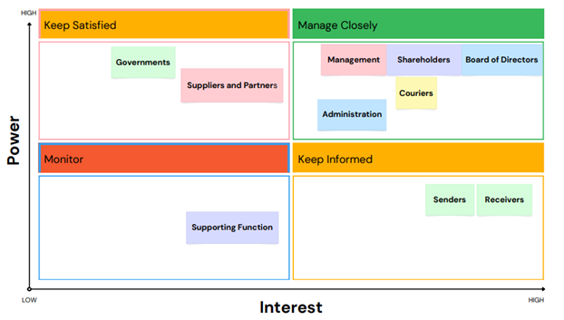

**Figure 2.3 – Power-Interest Grid including involved stakeholders**

Additionally, it is important to map the requirements and expectations each involved stakeholder has in DHL in order to improve the business process. The requirements of the involved stakeholders are the attributes, traits or features that the stakeholders view as necessary to the business process. Expectations of the involved stakeholders are the wishes or desires of the stakeholders they have in relation to the outcome of the business process. Table 2.2 shows an overview of the requirements and expectations of the involved stakeholders

|  |  |  |
| --- | --- | --- |
| *Stakeholder* | *Requirements* | *Expectations* |
| Board of Directors | Transparent reporting of DHL, alignment of interests and strategies, minimisation of risks and sustainability of finances. | Maximisation of stakeholder value, informed decision-making and effective governance of DHL |
| Management | Effective leadership and clear strategic direction (goals, values and mission), ensuring the business operations are conducted in an efficient and effective manner (minimisation of costs and maintenance and/or improvement of product and service quality) | Leadership which is both strong and effective in carrying out the mission, values and beliefs of DHL, transparency in communication with stakeholders, achieving strategic objectives or organisational goals, installing innovative culture |
| Couriers | Good, healthy and safe working conditions with appropriate employment conditions, appropriate equipment and clear instructions, good salary and promotion or growth opportunities | Clear and good communication, good management, clear and efficient delivery routes, recognition and rewarding of efforts and achievements |
| Administration | Efficient and effective working processes, thorough storage and procession of records and data, clear communication and administrative support | Quick responsiveness to inquiries, policies and procedures are followed obediently, and administrative tasks which promote operational excellence is managed in an effective manner. |
| Supporting Function | Responses that are prompt when needed. Cooperation is effortless and allows for support services that are effective and efficient | Assistance can be applied effortlessly in solving issues and helps to foster seamless operations and top performance |
| Senders | Timely and secure delivery of packages. High accuracy in package delivery. | Appropriate delivery options (drop-off points, premium, standard, etc.), effective and accessible customer service, continuous and transparent tracking of package deliveries |
| Receivers | Timely and secure delivery of packages. High accuracy in package delivery. | Appropriate delivery options (drop-off points, premium, standard, etc.), effective and accessible customer service, continuous and transparent tracking of package deliveries |
| Shareholders | Profitability of DHL, maximisation of shareholder value, distribution of the profits of DHL to shareholders as dividends, corporate governance practices should be done responsible and fair | Return on their investments (maximum profit), risk mitigation, abiding ethical responsibilities, transparency of finances, stability and durability of performance over long period of time |
| Suppliers/Partners | Timely payments, productive partnerships and effective collaborations, mutual reliability and transparency | Communication transparency and fruitful correspondence, partnerships should be reciprocally beneficial, fair treatment |
| Governments | Obedience to the law and safety standards, consideration of environmental policies and regulations | Abiding the law, punctual or prompt reporting of relevant (or important) issues, cooperation of DHL |

**Table 2.2 – Requirements and Expectations of involved stakeholders**

As such, the requirements and expectations of the stakeholders in combination with the power-interest grid can be used to make an analysis. It is evident that there are multiple important stakeholders in the context of DHL. For the specific case of DHL, the important stakeholders are – **The managers, couriers, administration, senders and receivers**.

These stakeholders are either are labelled as **managed closely** (managers, administration, couriers) or **keep informed** (senders, receivers). This finding is consistent with the analysis conducted on the strategy, mission and values of DHL, in which operational excellence is the main value discipline. Elements of the value disciplines of customer satisfaction and product leadership are also evident in the power-interest grid, as it coincides with the other stakeholders – **The governments, suppliers, senders** and **receivers**. Table 2.2 already shows some problems associated with the business process. This has to do with the goal of the management and shareholders to minimise costs and maximise profit for DHL. However, minimising costs would mean that you would need to reduce costs elsewhere such as lowering wages and bonuses for achievements of employees, increase in delivery charges for senders and receivers, or changing payout systems for couriers in a detrimental way. This could lead to dissatisfied customers who do not agree with the price changes, or demotivated employees who do not want to work for lower wager and become less accurate, timely and secure in the delivery operations or administration. Subsequently. this will create tensions between management and shareholders, which would then ironically see costs increase and profits diminish due to their initial lack of judgement.

These conflicting demands need to be addressed and resolved to fulfil operational efficiency. The customers will be satisfied when there is an appropriate delivery option which suits them best. When there is a transparent package tracking system available for the customer, this will also give a sense of security and the customer will be prepared to pick up or receive their package and utilise the delivery service again. The courier will work extra motivated when proper employment conditions are upheld with clear and good bonuses and payout systems that reward effectiveness. This will increase the effectiveness and efficiency of the delivery system which operations depend on the performance of the employees. This cycle will promote new customers to use DHL and old customers to keep using DHL. This will increase the revenue and will please the shareholders as profits can be made and costs can be minimised by management, relieving the tension between both parties.

**2.6 – Balanced Scorecard and Strategy Map**

Naturally, financial concerns are not the only factors that could create tension. It is important for a business to be able to balance multiple factors in order to prevent tensions to arise. This can be done and evaluated in a **Balanced Scorecard (BSC)**. The Balanced Scorecard evaluates four perspectives: **financial**, **customer**, **internal** and **growth and learning** (Kaplan & Norton, 2001).

* **The financial perspective** reflects on the point of view of shareholders and how they view the business.
* **The customer perspective** reflects on the point of view of customers and how they perceive the business.
* **The internal perspective** reflects on which business process(es) which are in need of improvement.
* **The growth and learning perspective** reflects on how employees in the business operations can improve and create value.

These four perspectives help to create an overview of the aims and goals of a business, contributing to successfully achieving strategy and goals (Janssen, 2024). The BSC will make sure that there is a equilibrium, which will help to prevent measures or improvements made in the business process to negatively affect other areas in the business process. The Balanced Scorecard shown in Figure 2.4 shows an overview of the important objectives regarding the managers, couriers, administration, senders and receivers. In this figure, **the objectives** of the stakeholders are balanced. Here the objectives of for instance the management (increase efficiency and profitability of delivery operations) are balanced with the objectives of the receivers and suppliers (Maximise customer satisfaction). The objectives of the receivers and suppliers are then balanced with the objectives of the administration (Optimise operational efficiency).

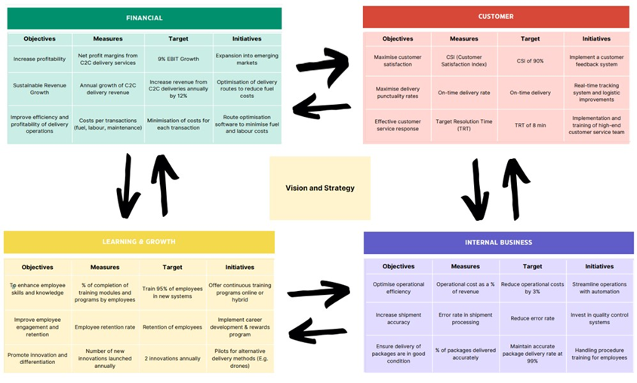

**Figure 2.4 – Balanced Scorecard of DHL**

In order to get a better understanding of how the objectives of the involved stakeholders influence each other a strategy map is made. This strategy map is shown in Figure 2.5. A **strategy map** links the different objectives with each other and helps to establish what the relationships and shortcomings are of the objectives.

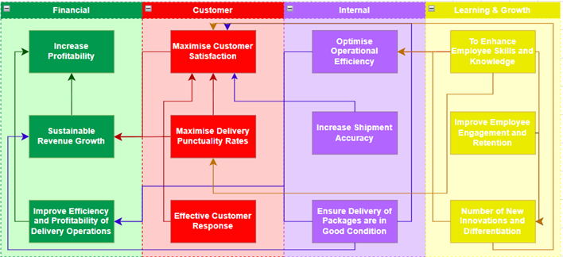

**Figure 2.5 – Strategy Map of DHL**

**2.7 – Selection of the critical business process**

In summary, this chapter delved into DHL as a business. Through a extensive analysis, utilising several tools and frameworks, such as the Ansoff Matrix, Value Discipline Model, Market and Stakeholder Analysis, Balanced Scorecard and a Strategy Map, it was possible to identify and gain knowledge on the business strategy, key stakeholders, and relevant objectives related to how DHL conducts business. The strategy of DHL aims to achieve operational excellence, while some elements of customer satisfaction and product leadership cannot be ignored. DHL hopes their approach will help them in penetrating more markets whilst continuing to develop their products and services in order to maintain their position as leaders in the market.

The involved stakeholders where identified to be the managers, couriers, administration, senders and receivers. It is important to map possible tensions which could surface between these stakeholders. These are shown in the balanced scorecard and strategy map, in which the objectives of the stakeholders are balanced in terms of view perspective.

Considering all that is mentioned, the critical business of DHL that is identified and needs to be addressed in more detail is determined to be: ***C2C Delivery Management System, specifically on the Outbound Logistics process***. This business process is essential to the goal of DHL to excel in operational excellence and is highly relevant for all the objectives of the stakeholders. In the following chapter, this business process will be described and modelled. It will describe and model the current business process, including the involved stakeholders, a description of the process, including a BPMN, and the perceptions of the stakeholders.

Sources

Matrix and Model

* <https://www.marketingmodellen.com/waardestrategieen-van-treacy-en-wiersema/>
* <https://www.bobstanke.com/blog/ansoff-matrix>

Text

* <https://group.dhl.com/en/about-us.html>
* <https://group.dhl.com/en/about-us/the-group/strategy.html>
* Reader
* <https://craft.co/dhl/competitors>
* <https://www.fedex.com/nl-nl/shipping/rates.html>
* <https://www.dhlecommerce.nl/nl/consument/support/verzenden/tarieven>
* <https://www.postnl.nl/api/assets/blt43aa441bfc1e29f2/blte8883fa2a17b41f3/65b8c9b3ba1594040a06dfc7/tarievenfolder-1februari-2024.pdf>

Models

* Canva Power-Grid Curve, balanced scorecard and strategy map – <https://www.canva.com/design/DAF_5ni-7Kc/-zwHzht0munSFHR_jcWNgA/edit>

# The Current Process

In this part, we will focus on analysing the current process on the critical business process that we have chosen on the previous chapter: C2C Delivery Management System, specifically on the Outbound Logistics process (Last Miles delivery).

Involved Stakeholders

Among all of the stakeholders analysed on the previous chapter, the direct contributions are done by two groups: Customers and DHL internal system:

1. Customer

Customers are defined as the users of the services that DHL provides. Here, we will focus on the sole customer (hence C2C), not the business customer. C2C is the fastest growing part of DHL portfolio in Benelux region [1]. In addition, understanding the business process from the simplest point “the customer” is a good start in creating a more customer-centric design. By starting as the customer, it is also easier for us to empathize on what the customers feel as we are facing these kinds of services commonly in our daily life. This approach can lead to higher customer satisfaction and loyalty [2]. Lastly, starting flow simplest part will allow us to further improve into more complex business flow, for example: B2B, B2C, etc. Generally, the customers are divided into two main roles:

* Sender: individuals who prepare the parcels or package and send it via DHL Express. They have the main responsibility to handle directly the packages to DHL.
* Receiver: individuals who receive the packages from the senders at a certain point or address. They have the main responsibility to physically receive or take the package handed by DHL.

Beyond these two main responsibilities, it is assumed that Receiver and Sender have internal communication to share information (especially address) and transfer money.

1. DHL internal system

The internal system of the DHL will be simplified into two main functions:

* DHL Administration: handles all the information flow when the operations start, including: required form and data, payment, assigning the couriers, giving routes and important information in warehousing and outbound logistics, and feedbacks. If the Senders opt to give the packages on the dropping point (instead of pick up by the couriers), the DHL Admins will be responsible to assign it to the couriers.
* DHL Courier: handles the flow of physical package from warehousing to the Receiver. They have to follow the instructions from the DHL and do reporting.

These stakeholders re-definition is the starting point of creating the BPMN, because each of them will be represented by the Swim Lane diagram.

Model and Description

Assumptions

Reference that I used here:

[1] https://www.dhl.com/global-en/delivered/ecommerce/consumer-to-consumer-e-commerce.html

[2] <https://www.forbes.com/sites/forbesbusinesscouncil/2023/07/18/why-customer-centricity-is-a-key-to-long-term-success/>

[3] SCM MIT: Past Present and Future: <https://ctl.mit.edu/sites/ctl.mit.edu/files/attachments/SCMR1703_F_Celebrating20Years.pdf>

# Diagnosis of the Issues

* Customer Requirements
* SWOT Analysis
* The Issues (Problem Definition)
* Root Cause Analysis

# The Improved Process

* Model and Description

* Assumptions

# Implementation of the New Process

This chapter further complement the desired business process by analyzing the financial benefit, project plan, and respond to potential risks. These are the most important frameworks to make sure that the improvements will gives positive value added to the DHL company.

Cost-Benefit Analysis

To evaluate the cost and benefit, we will mainly use Activity Based Costing (ABC) framework. Zoltan (2015) argues that ABC costing is a useful tool in logistics management since analysis can be carried out in a more exact basis. In addition, since logistics are complex field and we will give several options of services to customer (Premium, Regular, Economical), we need to inspect which process in the overall logistics business process contribute to the final service.

To apply the ABC Costing, some important figures are carried out via these steps:

1. Cost Projection. Steps done in this calculation:

* The cost components of the new services are based on the similar research by Zoltan (2015) who analysed the cost of three services for customers in a logistics company. Group 20 simplify all the components into only 6: from Sales until Supplementary Services, all depicted on figure below.
* The Annual Operating Expense, AOE (€1500 million) were estimated calculating current DHL Express revenue, profit, and ROS (Return of Sales). By assuming that currently DHL only operates Regular and Economics with prices stated on its official website [1], we will get the current revenue (€1724.25 million). As stated on the 2023 Financial Report of DHL [2], the ROS is around 13%, thus we will get the profit figure. Finally, AOE of DHL Express is simply Revenue – Profit. We need to do this because AOE of DHL Netherlands are not specified on the Financial Report.
* Based on the 2023 DHL Financial Report Transportation Component accounts for >50% of overall operating expense! Using this strong basis, we choose around 50% (51.3% to be exact) of the AOE as cost of Transportation Component. The rest components will be based on the Zoltan’s research[1] after normalizing with this 51.3% number.
* We define that Premium service requires delicate Planning, Transportation and its additional insurance (because we give insurance of reschedule max once), and supplementary services (prioritized tracking, customer service, etc). Regular are similar with Premium, but without advanced Planning algorithm. Finally, since package will be delivered to Drop Point. Store, Economical does not require Supplementary Services.

1. Revenue Projection. Steps done in this calculation:

* We need to estimate the price of each services. To penetrate the market, we use the strategy of Setting the Price [3] by comparing with the competitors. The price of Regular in DHL Express stays the same with current price, while Economical will be lower and Premium will be higher (we set the price a little bit lower against PostNL[4]). Finally, fine tuning or adjustment is needed in the until we meet the desired Revenue and Profit.

The price of package for Premium is 10 euro/package (PostNL is 14.9 eur), Regular is 6.45 eur/package (same with current DHL price), and Economical 4.25 eur/package.

* To estimate the number of package sends in this new services, we use two most important figures: number of package sends in the Netherlands per year [5] and the DHL marketshare[6] which is around 30%.
* Using ABC Inventory (Pareto Principle) rule of thumb: 20:30:50, we expect that 20% of customers in the Netherlands will use Premium, 30% Regular, and 50% Economical.
* The expected revenue is gained by multiply the number of annual packages send in each of the services with the price per packages.

1. Profit Calculation: It is not stated in DHL Financial Report on how much profit of the DHL Express current system (As-Is) in the Netherlands, thus we compare the profit between the Improvement business process with As-Is, assuming that current DHL only applies Regular (60% share) and Economical services (40% share).

In summary, total expected revenue of the new system is €1727.1 million, resulting in profit of €247.67 million or increases by 10.49% compared to current DHL Express business. To validate this number is logical, we compare with the Revenue of DHL Express in Europe (stated on the Financial Report), that this €1727.1 million accounts for 16% of entire Europe DHL Express Revenue. We think this number makes sense because it is not way too big (>50%!) or too small.

The summary can also be seen on the table below. The detailed calculation is on Appendix 1.

|  |  |  |  |  |  |  |  |  |  |  |  |
| --- | --- | --- | --- | --- | --- | --- | --- | --- | --- | --- | --- |
| **No** | **Service** | **Improvement** | | | | | **As-Is** | | | | |
| **Price** | **Share** | **Annual Revenue** | **Operating Cost** | **Profit** | **Price** | **Share** | **Annual Revenue** | **Operating Cost** | **Profit** |
| 1 | Premium | 10 | 20% | 570.0 | 500.0 | 69.9 | 0 | 0% | 0 | 0 | 0 |
| 2 | Regular | 6.45 | 30% | 551.4 | 450.0 | 101.4 | 6.45 | 40% | 1102.9 | 900.0585 | 202.8 |
| 3 | Economical | 4.25 | 50% | 605.6 | 529.4 | 76.2 | 5.45 | 60% | 621.3 | 600.039 | 21.2 |
|  |  |  |  |  | Total | **247.6** |  |  |  | Total | **224.1** |

Project Plan

Mitigation Plan and Risk Analysis